Chapter 6, Solution 76.

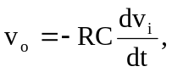 RC = 50 x 10³ x 10 x 10⁻⁶ = 0.5
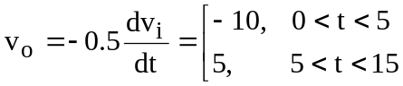

The input is sketched in Fig. (a), while the output is sketched in Fig. (b).
15
(a)
10
0
100
5
v_{i}(t) (mV)
t (ms)
-10
15
(b)
10
0
5
5
v_{o}(t) (V)
t (ms)

